Installing VirtualBox on your Mac

1. Go to [VirtualBox’s download page](https://www.virtualbox.org/wiki/Downloads) and click “OS X hosts”. A .dmg file should be downloaded to your “Downloads” folder.

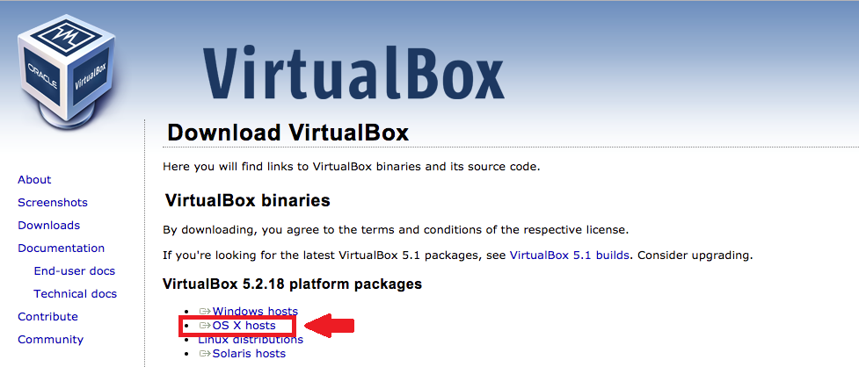

1. Open the downloaded VirtualBox .dmg file. You will see a screen like this:

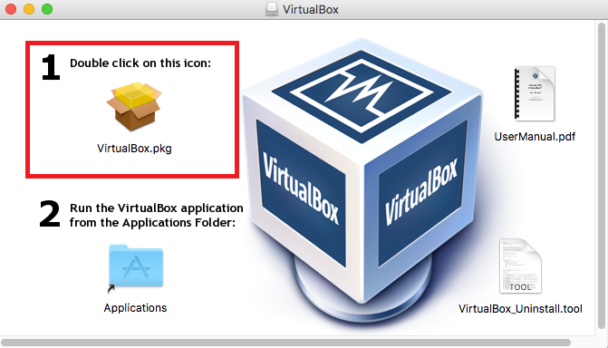

1. Double click on “VirtualBox.pkg” to start the installer
2. When you see a prompt like below, click “Continue”

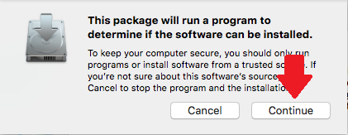

1. The installer is now open. Click “Continue”

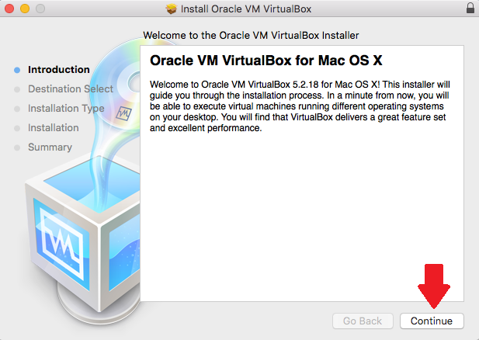

1. You can change where you want VirtualBox installed, or leave the default option and click “Install”

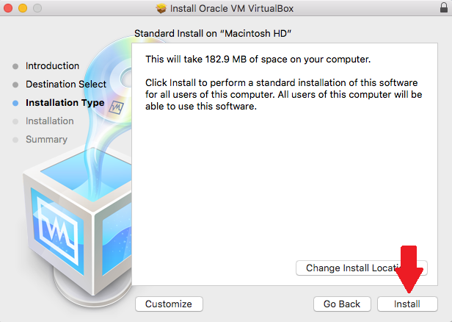

1. When prompted with an authentication screen, enter the username and password for your user and click “Install Software”

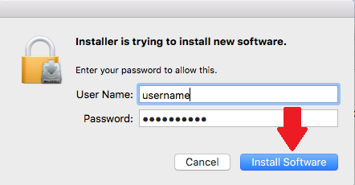

1. If you see “The installation failed” screen, then the installer was blocked.

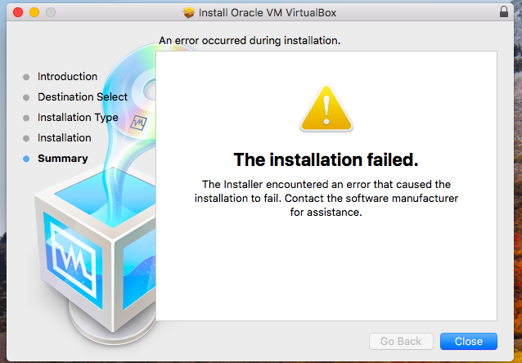

1. Click on the apple logo in the top left and click “System Preferences”

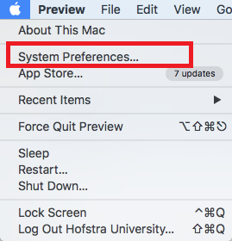

1. Click the “Security & and Privacy” option

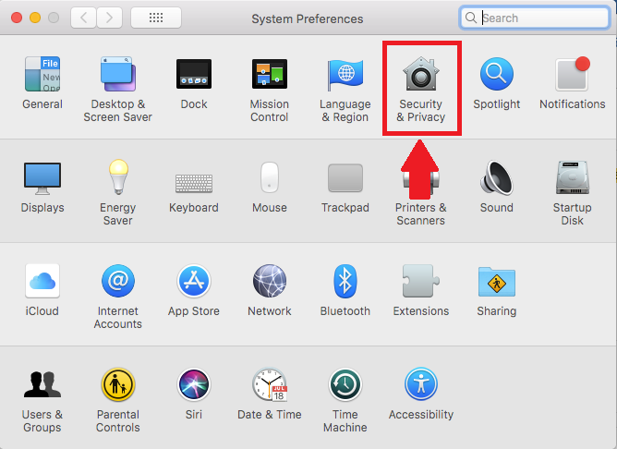

1. Click the padlock icon to allow you to make changes. Then click “Allow” next to the message that software from “Oracle America, Inc.” was blocked.

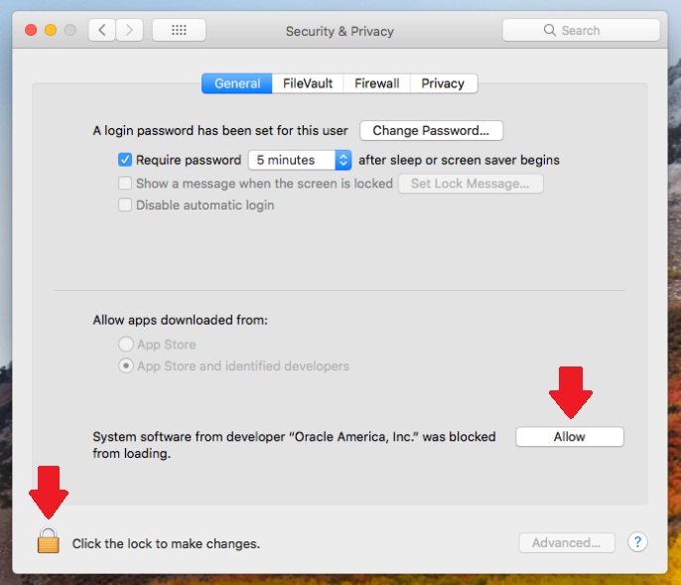

1. Rerun the installer the same way as before.

After the installation completes, VirtualBox will be in your “Applications” folder.